Neural Networks
Ref. No.: NEUNET-D-25-05585R2

DSN: Energy-Efficient EMG Signal Classification Method Enabling Real-Time Monitoring for Edge Healthcare

Response Letter to Reviewers’ Comments

Comments from the Editor:
The remaining reviewer acknowledged the improvements of the revised manuscript, while there are still several minor but important concerns remained to be addressed. The authors are suggested to carefully check the whole text in addition to the pointed parts.

Response: Thank you very much for your decision and recommendation. We greatly appreciate that our article is considered acceptable for publication pending minor revisions. We have carefully addressed all concerns raised by the reviewer, revised the manuscript accordingly, and performed a thorough check of the entire text for consistency and typos. All revisions are highlighted in yellow. We believe the manuscript now meets the journal’s requirements for publication. We summarize our works below:
The proposed DSN framework addresses the challenge of energy-efficient sEMG-based muscle fatigue classification by integrating two complementary neuromorphic paradigms: Spiking Neural Networks (SNN) and Hyperdimensional Computing (HDC).
The pipeline begins with a preprocessing stage that applies a 20–350 Hz band-pass filter and extracts eight multi-domain features (three time-domain: IEMG, MAV, ZC; five frequency-domain: MNF, MDF, PKF, FR, WENT) to capture both the intensity and spectral dynamics of fatigue.
These features are fed into a single-layer SNN with 128 LIF neurons. Rather than iterative backpropagation, the SNN performs only a single forward-backward pass at initialization with Gaussian-initialized weights, producing sparse firing-rate representations over T=10 time steps. This design is theoretically grounded via a piecewise-Lipschitz stability analysis (Theorem 1).
The spike-rate features are then projected into a high-dimensional binary space (HDC encoding) via a fixed random projection matrix, and binarized using the sign function. Class prototype hypervectors are formed by bundling same-class samples, and classification is performed via Hamming distance matching. The HDC module is supported by three theorems guaranteeing robustness to input noise (Theorem 2), representational fidelity of cluster prototypes (Theorem 3), and resilience to hardware bit-flip errors (Theorem 4).
Experiments on the public Cerqueira dataset demonstrate 94.40% accuracy with up to 12.03× lower training energy than LSTM, while maintaining over 90% accuracy using only 20% of training data.
---------------------------------------------------------------------------------------------------------------------

Reviewer #2:

I appreciate the authors' detailed response and the effort made in revising the manuscript. Some of my previous concerns have been addressed to a considerable extent. However, after carefully checking the revised manuscript and the response letter, I find that several issues still remain, as detailed below:

Response: Thank you very much for your careful review and constructive comments on our revised manuscript. We sincerely appreciate your recognition of our efforts and the progress made in addressing your previous concerns. We take your remaining comments very seriously and have carefully revised the manuscript point by point according to your suggestions. All revisions have been clearly marked in the revised manuscript, and detailed responses to each of your remaining concerns are provided below.

1. According to the authors' response, since the SNN has undergone a backward pass and one weight update, it seems inappropriate to continue using or implying statements such as "untrained" or "does not rely on backpropagated weight optimization." The authors should revise the wording accordingly, or provide relevant references/methodological justification to support the consistency between the proposed "one-shot" update and such descriptions. In particular, the statement in Section 4.8, "Because the SNN does not rely on backpropagated weight optimization," appears inconsistent with the authors' explanation that a single backward pass and one weight update are performed. The authors are advised to harmonize the related descriptions throughout the manuscript.

Response: We have harmonized all descriptions of SNN training throughout the manuscript. All phrases such as "untrained" and "does not rely on backpropagated weight optimization" have been removed. We now uniformly state that the SNN performs a "lightweight one-step forward–backward pass with a single weight update at initialization, rather than iterative backpropagation-based weight optimization," including the key sentence in Section 4.8. We have also clarified in Section 3.3 that the "no-backpropagation" wording refers specifically to the fixed random projection matrix W in the HDC encoding stage, not to the SNN. The relevant changes appear in the Abstract, Section 1, Section 3.2, Section 3.3, and Section 4.8. We further clarify that the term "random weights" retained in Section 4.7.1 and Fig. 8(b) is used solely as the label of an experimental control configuration in the trained-weight versus random-weight ablation; as the summary statement of that subsection explicitly states, this configuration corresponds to randomized initialized weights with a single one-step update, and it is therefore fully consistent with the harmonized training description above rather than implying an untrained network.
---------------------------------------------------------------------------------------------------------------------
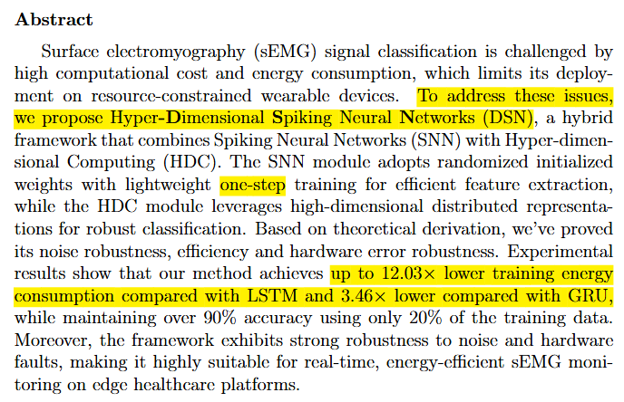
(See Abstract)
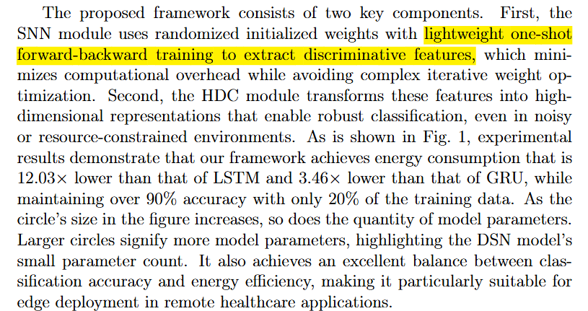
(See Section 1)
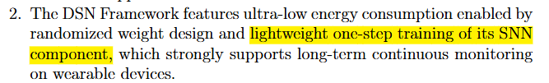
(See Section 1)
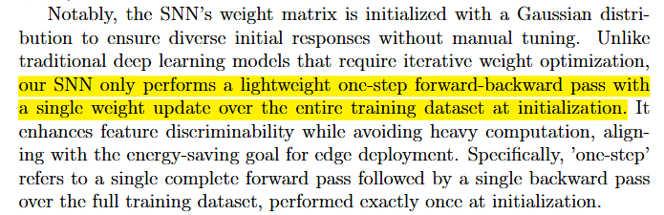
(See Section 3.2)
(See Section 3.2)
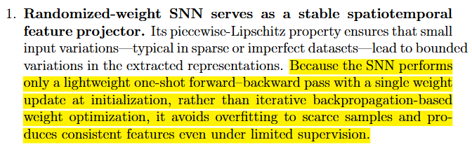
(See Section 4.8)

---------------------------------------------------------------------------------------------------------------------

2. At the beginning of Section 4.2, SVM is cited as SVM[35], whereas in Table 2 it is still cited as SVM[37]. Meanwhile, the method corresponding to reference [35] appears to be labeled as SNN in Table 2. This may be a typographical error, but the authors should carefully check and correct the citations of the related methods throughout the manuscript.

Response: We sincerely apologize for the typographical inconsistency in citations. We have carefully checked and fully unified all citations throughout the manuscript. Specifically, the citation for SVM has been corrected to [13] and the citation for SNN has been corrected to [21], making all in-text citations and Table 2 references completely consistent. All corrections have been highlighted in yellow in the revised manuscript.
---------------------------------------------------------------------------------------------------------------------
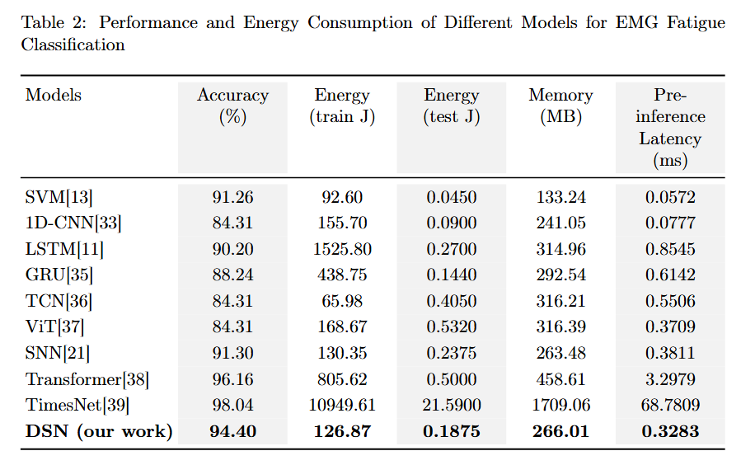
(See Table 2)
---------------------------------------------------------------------------------------------------------------------

3. Section 4.2 states that "The DSN model exhibited significantly lower energy consumption during both its training and testing operations compared to the other models." However, according to Table 2, the energy consumption of DSN is not the lowest in all aspects. The authors should revise this statement so that it is fully consistent with the results reported in the table.

Response: We apologize for the overstated claim. We have revised the statement to be fully consistent with Table 2 and no longer assert the lowest energy in all aspects. The revised text now reads that "the DSN model achieves highly competitive and substantially reduced energy consumption in both training and testing, outperforming most compared models and especially offering much lower training energy than LSTM and GRU. Specifically, its testing energy consumption was found to be notably reduced." We confirm that DSN does not claim the lowest training or testing energy across every baseline; rather, it offers the best overall accuracy–energy trade-off for edge deployment. The revision is highlighted in yellow in Section 4.2.
---------------------------------------------------------------------------------------------------------------------
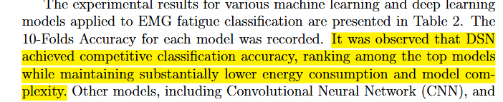

(See Section 4.2)
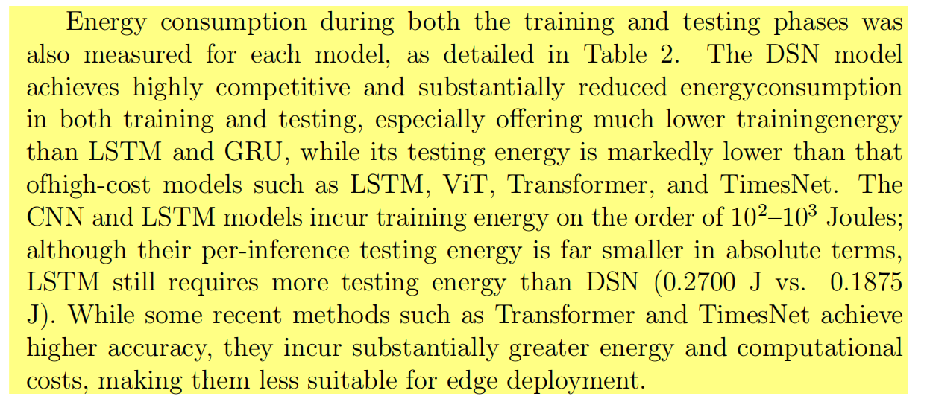
(See Section 4.2)
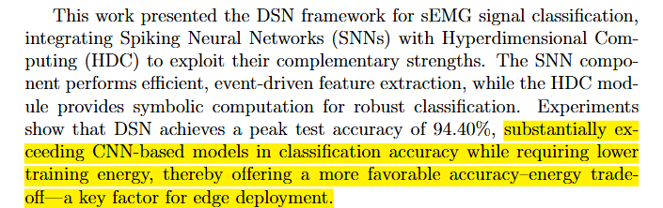
(See Section 5)
---------------------------------------------------------------------------------------------------------------------

4. At the beginning of Section 4.3, the phrase "the confusion matrices for the DSN, 1D-CNN, LSTM and DSN models" repeats DSN twice. This appears to be a typographical error and should be corrected.

Response: We apologize for the typographical error with the repeated “DSN”. We have corrected the sentence by removing the duplicate term, and the revised text is highlighted in yellow.
---------------------------------------------------------------------------------------------------------------------

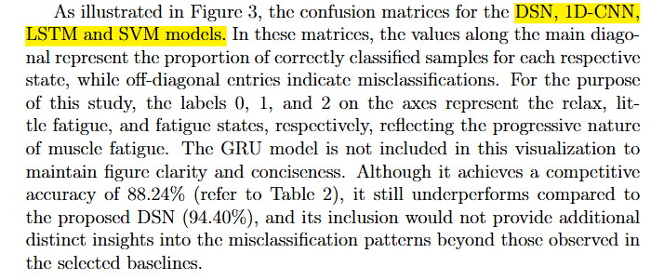
(See Section 4.3)

---------------------------------------------------------------------------------------------------------------------

- The energy-reduction claims appear to be reported using different bases in different parts of the manuscript. The abstract/introduction report "12.03× lower" energy consumption compared with LSTM, whereas the conclusion reports "1.44×." If these values correspond to training energy and testing energy, respectively, this should be explicitly stated; otherwise, the claims should be harmonized throughout the manuscript.
Response: We apologize for the inconsistent energy-reduction claims. The values refer to different metrics: 12.03× lower training energy (abstract/introduction) and 1.44× lower testing energy (conclusion). We have explicitly labeled both metrics in the revised manuscript, and all changes are highlighted in yellow.
---------------------------------------------------------------------------------------------------------------------
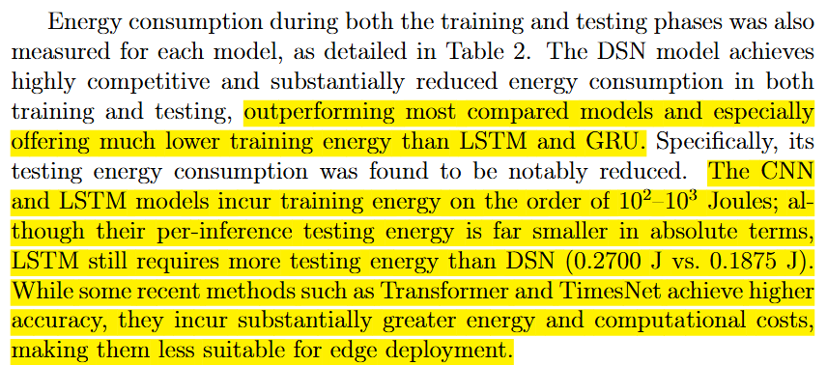
(See Section 4.2)
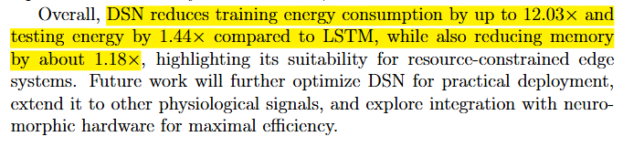
(See Section 5)
---------------------------------------------------------------------------------------------------------------------
- The acronym "DSN" is used multiple times before it is first defined in Section 4.2. The authors should define this acronym at its first occurrence. In addition, the expansion "Deep Supervised Network" appears somewhat disconnected from the proposed SNN-HDC framework, so the authors should carefully check whether this naming is accurate and consistent with the method described throughout the manuscript.
Response: We have added a clear definition sentence at the first occurrence of DSN in abstract, specifying DSN (Hyper-Dimensional Spiking Neural Networks) to align with our hybrid framework. The inaccurate "Deep Supervised Network" has been removed. Changes are highlighted in yellow.
---------------------------------------------------------------------------------------------------------------------
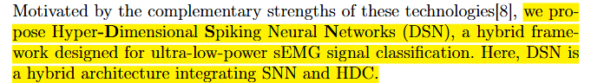
(See Section 1)
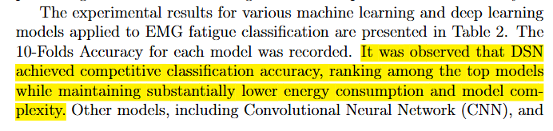
(See Section 4.2)
---------------------------------------------------------------------------------------------------------------------

